***Statistics Notes - 4***

Pearson’s r Correlation:

A **linear relationship**is where you represent the relationship between variables as a *line* (the word comes from the Latin *linearis*, from *linea*“a line”). If there’s no straight line, then it’s non-linear.

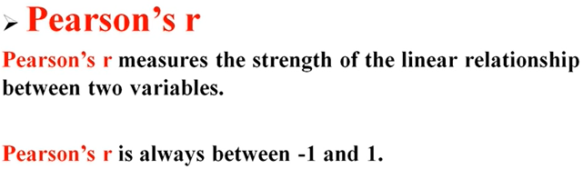

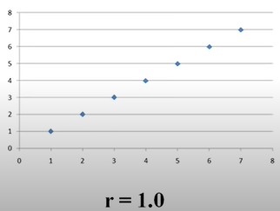 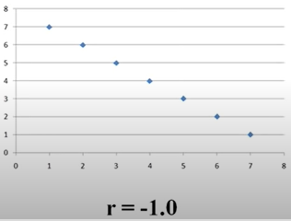

Our r would be 1 when we have perfect positive relationship it means X increases Y also increases whit exactly with the same way. And the r will be negative offsets are true means Y increases X decreases. And is r = 0 then there would be no relationship.

* A correlation coefficient of 1 means that for every positive increase in one variable, there is a positive increase of a fixed proportion in the other. For example, shoe sizes go up in (almost) perfect correlation with foot length.
* A correlation coefficient of -1 means that for every positive increase in one variable, there is a negative decrease of a fixed proportion in the other. For example, the amount of gas in a tank decreases in (almost) perfect correlation with speed.
* Zero means that for every increase, there isn’t a positive or negative increase. The two just aren’t related.

The [absolute value](https://calculushowto.com/absolute-value-function/#absolute) of the correlation coefficient gives us the relationship strength. The larger the number, the stronger the relationship. For example, |-.75| = .75, which has a stronger relationship than .65.

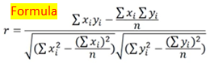 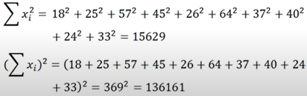

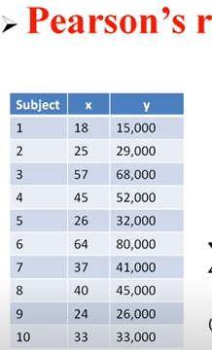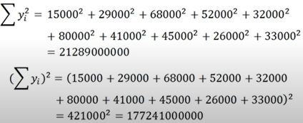

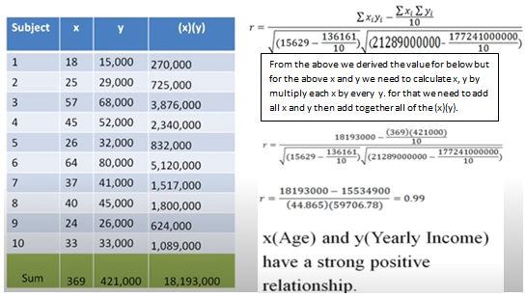

***Hypothesis testing with Person’s r:***

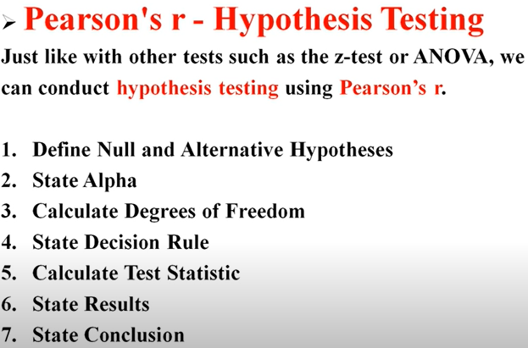

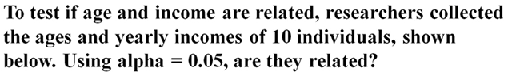

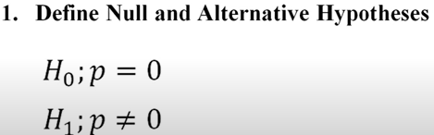 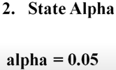 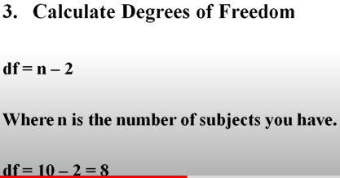

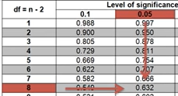 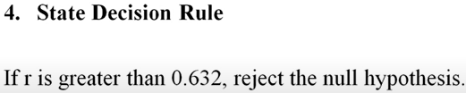 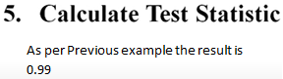

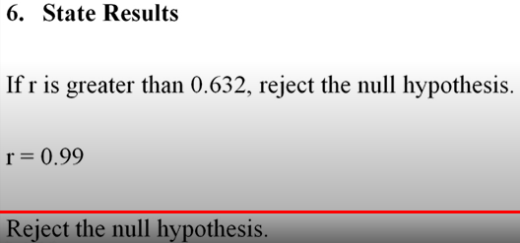 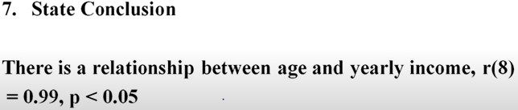

***Spearman Correlatio :***

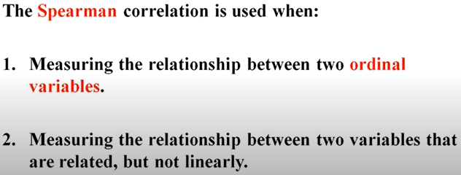

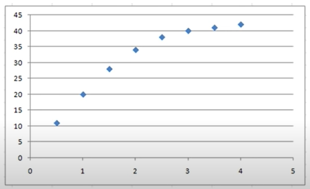

In the above diagram we cannot draw a line through that but there is some relation between these of two. Just look at the below example for more explanation:

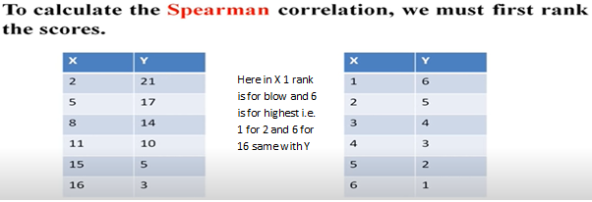

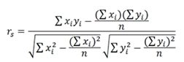 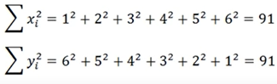

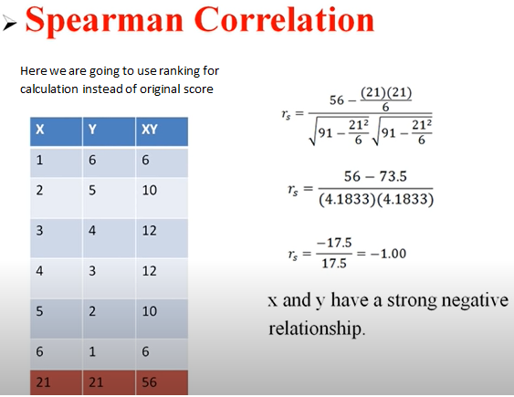

***Linear Regression*:**  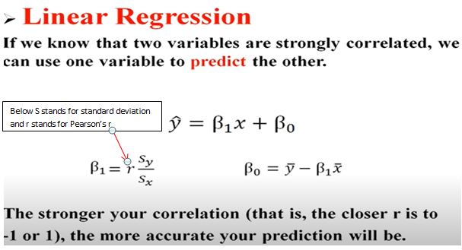

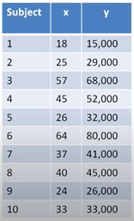 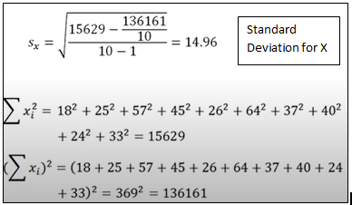

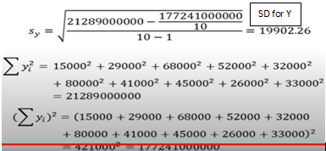 

Now for the below formula we have calculated β1 but now we have to calculate mean for X and Y

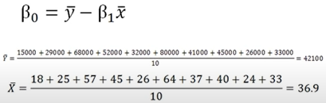



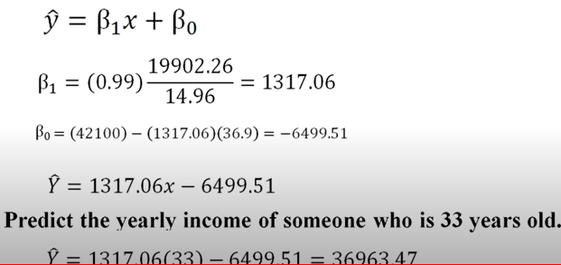

**Correlation and Causation**:

**Parameters, Statistics and Sampling Error**:

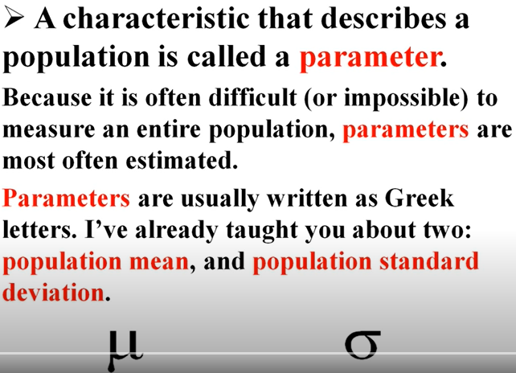

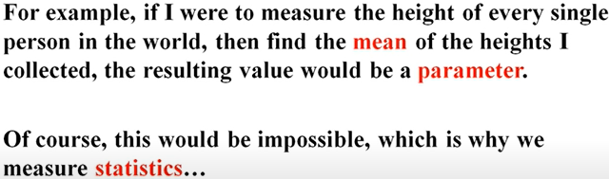

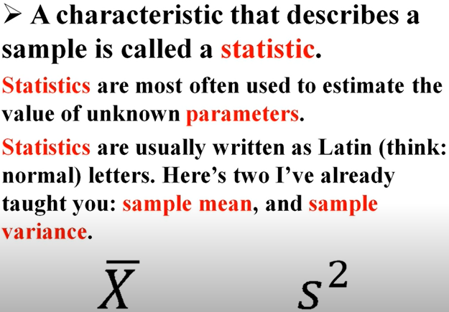

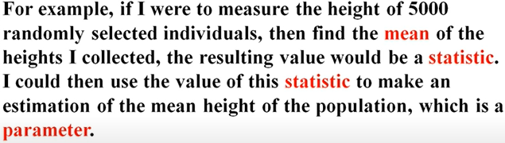

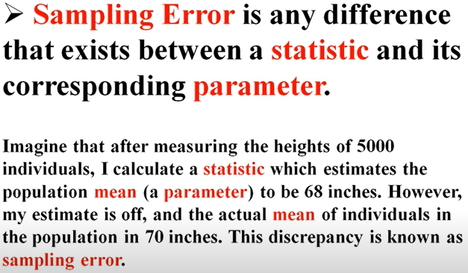

**Distribution of the Sample Mean**:

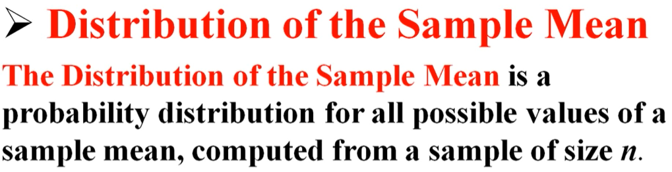

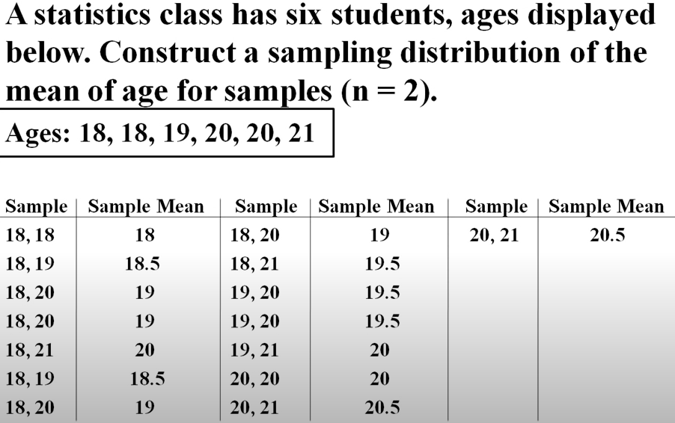

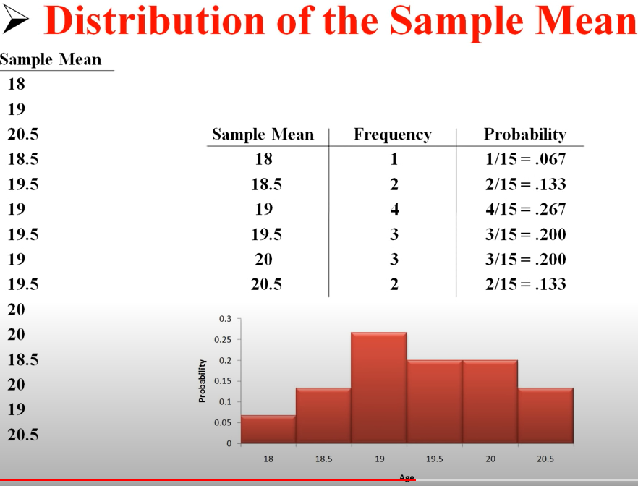

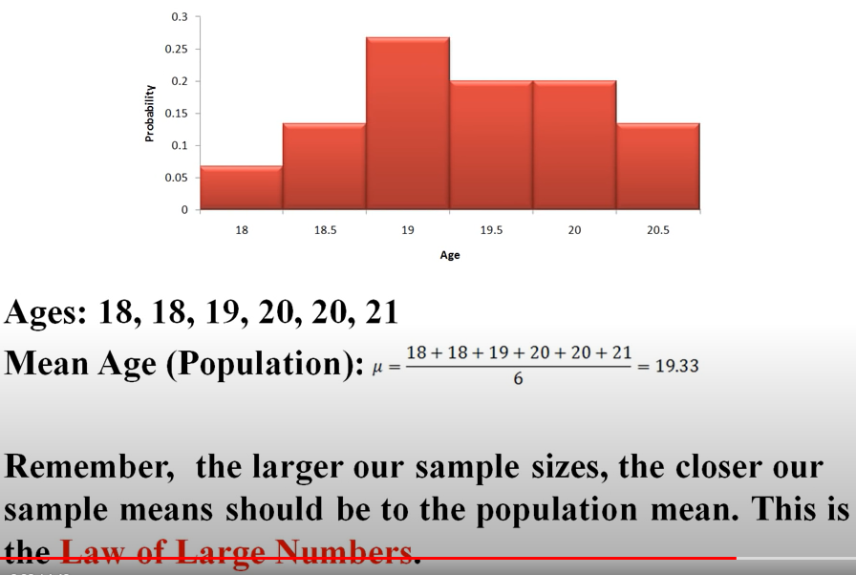

Standard Error of the Mean

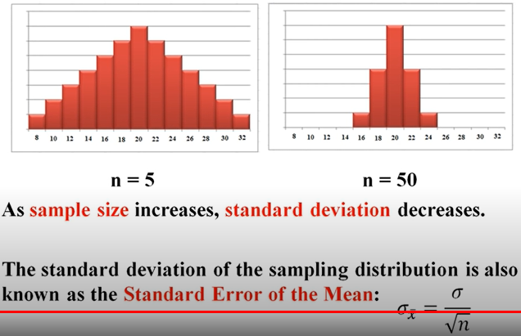

**Then Central Limit Theorem**:

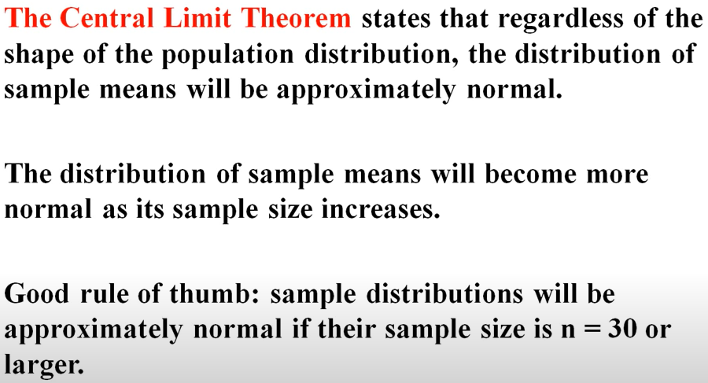

**The Central Limit of Theorem**:

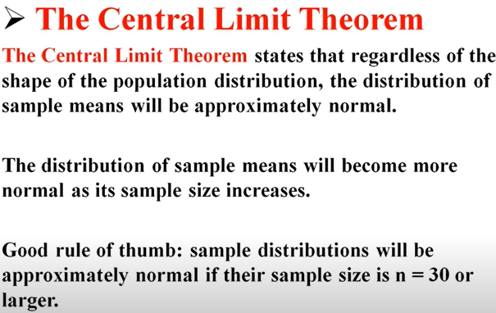

**Sample Proportions**:

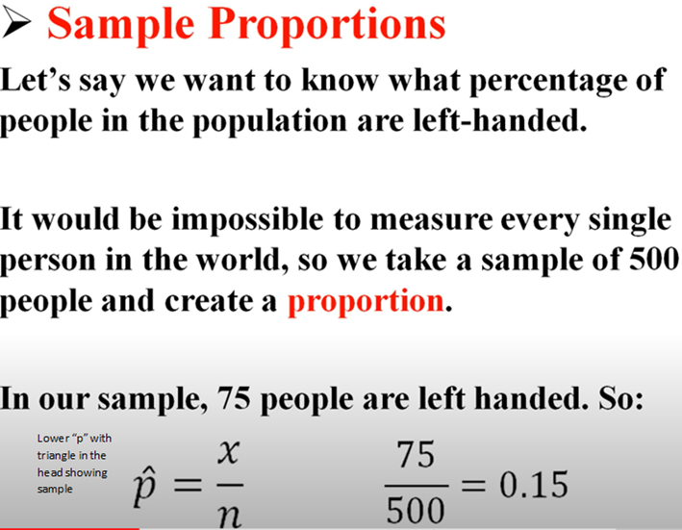

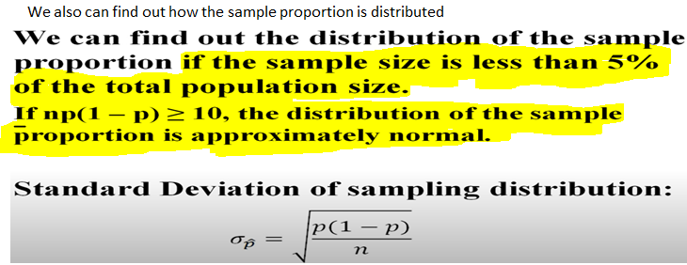

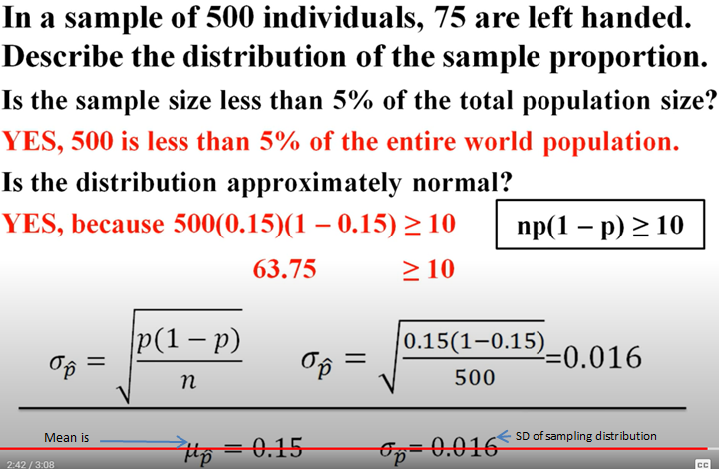

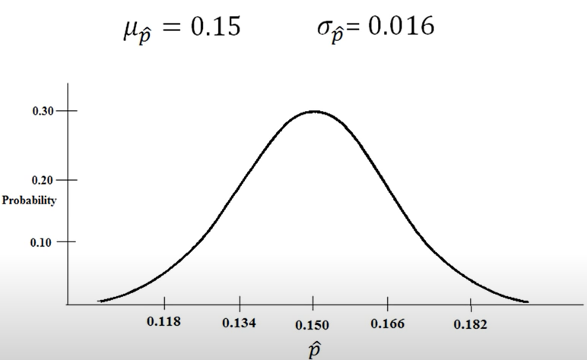

**Confidence Intervals about the Mean, Population Standard Deviation Known**:

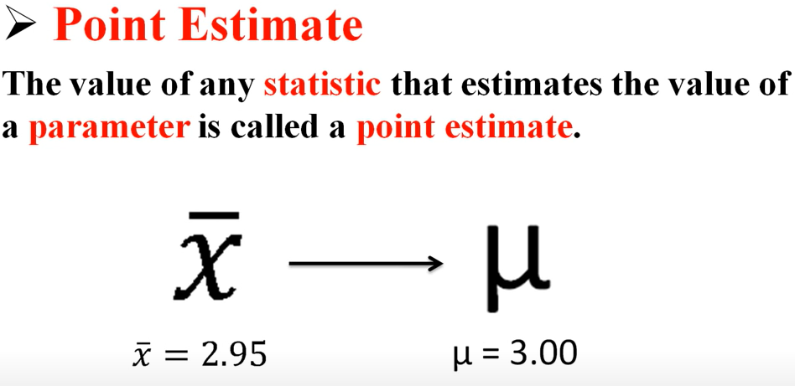

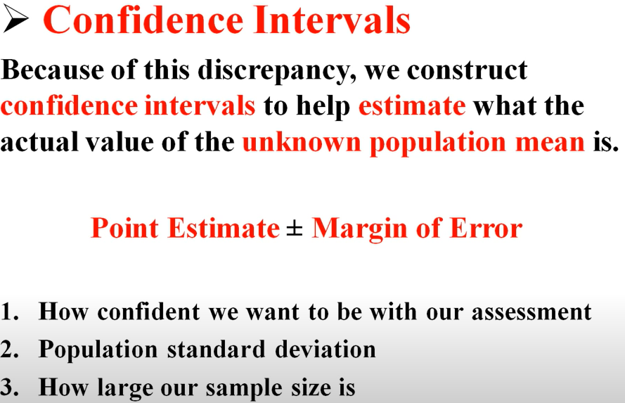

Not fully understand hence screen shot not taken for remaining part.

**Calculating Required Sample Size to Estimate Population Mean**;

For the above topics check z score topics

**Student’s t-Distribution**: